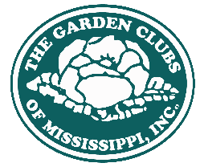
FLOWER SHOW AWARD APPLICATION 2023-2024

Please remember that notice of intent to apply for an award should be made sixty (60) days before the show date for all Flower Show Awards. When planning shows and compiling Award Application Books of Evidence, please refer to the Handbook for Flower Shows, 2017 edition as well as corrections published in The National Gardener online.

TOWN | DISTRICT | POPULATION
NAME OF CLUB
THEME
DATE OF SHOW |  | PLACE OF SHOW:
NAME OF AWARD APPLYING FOR:
Name, Address and Status of Flower Show Judges who will serve:
See attached
Name, Address and phone (and email if preferred) of Show Co-Chairperson | Name  Address | Phone  Email
Club Info: Date Organized | State Affiliated | Membership
State and National Flower Show Awards won in the previous two years

Print and mail to Pattie Smith, 542 Northwoods Drive, Grenada, MS 38901
Or print and email this form to nabersgirl@icloud.com.

FORMS/ FLOWER SHOW AWARD APPLICATION 2021-2023

