The Garden Clubs of Mississippi
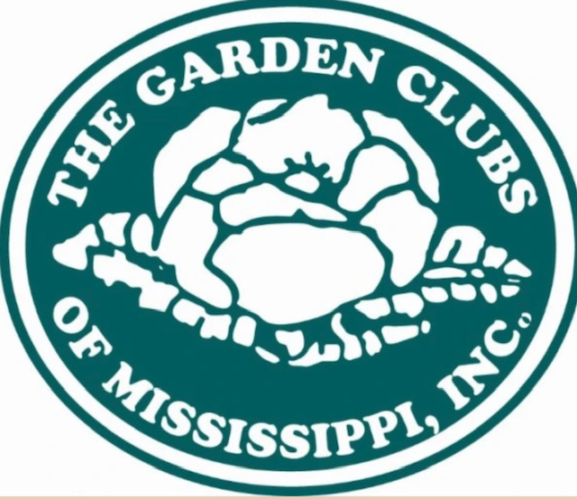
Smokey the Bear/Woodsy Owl Contest

2024 Smokey Bear & Woodsy Owl Poster Contest Rules
- Competition may include students from first to fifth grade.
- Posters are to be completed by individual student artists.
- Posters must have correct spelling (posters with spelling errors will be disqualified).
- All posters must feature Smokey Bear.
- Smokey Bear posters must include Smokey’s wildfire prevention message: Only You Can Prevent Wildfires!
- All posters should encourage children to take a personal role in preventing wildfires or conserving natural resources.
- Smokey Bear must be presented in his correct colors (he is an official icon protected by law); check the colors on the website www.fs.usda.gov/learn/kids or www.symbols.gov.
- Each poster entry should be 11 x 17 inches in size.
- Materials that can be used include crayons, markers, poster paints, watercolors, and the like.
- The choice of paper color and texture is up to the child.
- No three-dimensional posters, computer-scanned, or electronically generated images will be accepted. All poster entrees must be submitted to Chairman: Allison Ashmore, 2741 Sweethome Road., Grenada, MS 38901 flowersquaw@yahoo.com by January 20, 2024.
- The Garden Club chairperson must submit the poster entries to his or her state chairperson no later than January 20, 2024. The state garden club chairperson must submit the five winning posters from his or her state to the regional garden club chairperson by February 24, 2024.
- The following information should be written on the back of the poster in the lower-right corner (do not use a dark marker for this information as it may show through):
- The name, address, phone number, and email of the sponsoring local garden club.
- The artist’s name, address, contact phone number, grade level, school, teacher’s name, city, and State. (Should school policy preclude giving students’ addresses and phone numbers, please include the school address and phone number).

Poster Tips
- A good poster has a bold and simple design.
- The poster’s message should be easily understood and delivered both in the picture and in text.
- An educator, parent, guardian, or other adult should provide 11” x 17” paper for a child to create their poster.
- Find inspiration for your poster with promotional and educational products from the National Symbols Cache, www.symbols.gov.
- Posters will be judged for originality, design, slogan, artwork, and overall effectiveness of the message.

